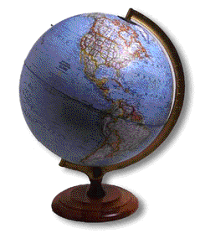
Demographics

Studying Populations

- Birth Rate in Quebec Lowest Since 1908
- Differing Population Growths
- Predicting Future Trends

Population Pyramids

- Population Pyramid Analysis
- Predicting Population Pyramids

Global Village

- Global Village of 100
- Global Village of 1000

Studying Populations Lesson Plan


Materials Required/Getting Ready:

- Chart paper with questions written for placemat activity –Power point projector.
- Student worksheet for power point presentation.
- Worksheet for population data activity
- Quebec article with questions for homework.
- World population data packages ready.

Lesson Plan:

- Placemat activity. Why should we be interested in studying populations? What factors might account for population growth? What factors might account for population decline? How can we measure populations (name some characteristics)? Purpose: formative assessment. The students write down as many responses in each section as possible (this is to be done in groups of four). They get 30-60 seconds for each. After each student has completed all four sections, they get two minutes to discuss their findings. They will be asked to put a star beside the top five in each category that they want to talk about (5-10 minutes).
- Discuss the findings. One group begins- why are we interested in studying populations? Other groups can contribute their responses. Another group talks about the findings for the second question, etc. I will elaborate on anything important that the students have missed with the power point presentation. Students are encouraged to take notes during the discussion (5 minutes).
- Lecture using power point: the difference between population geography, demography, and demographics; population growth (rate of natural increase, etc.); population decline (sub-replacement fertility, emigration, etc.); demographic variables; more developed countries versus less developed countries; other definitions. Students fill in sheet that goes with power point. Purpose: an introduction to the study of demography and its importance. Outlines some of the issues that will be discussed in subsequent classes (population growth, for example) and provides some basic definitions (15 minutes).
- Global Village of 1000 (still power point): students begin to think about how we are interconnected with the rest of the world. Introduces another aspect of human populations in regards to language, religion, income, etc. (5-10 minutes).
- Using Statistical Data. Create charts and complete worksheet. This will be done in groups because students will need to share World Population Data package (15 minutes). NB: Once students pull out the information they need from the package, they can work individually. Purpose: Gets students accustomed to working with population statistics and looking for trends.
- Quebec Case Study. Purpose: to help students understand the importance of the study of population statistics and the kinds of issues that can arise. If time, students can begin to work read article/respond to questions, else assign for homework.

Teacher Notes for PowerPoint:

Demography
  - Population geography is the study of SPATIAL distribution, composition, migration, and growth of populations over time.
  - Demography is the study of human population dynamics. Looks at how populations change over time due to births, deaths, migration, and ageing.
  - Demographics: the characteristics of population. For example – birth rate, death rate, age, income.
  - Demographics helps to analyze population change over time and can help us to predict future needs. It can be valuable to governments (schools, housing, health care centres), and also for consumer production.
  - Population change over time will inevitable affect political systems, economy, social structures, environment. The trends we observe can help us to make future predictions.

Population Increase
- Factors that may lead to population increase include:
  - Food
  - Health
  - Economic Growth
  - Migration
- Growth Rate - the number of persons added to (or subtracted from) a population due to natural increase and net migration.
  - Birth rate: number of live births per 1,000 population per year.
  - Death rate: number of deaths per 1,000 population per year.
- Rate of Natural Increase = birth rate – death rate = rate of natural increase
- Factors that contribute to the decline in death rate include:
  - Better Nutrition
  - Better Access to Medical Care
  - Improved Sanitation
  - Better Immunization
- Recent history of human population has been affected more by declines in the death rate than by increases in birth rate.
- Declines are due to public health measures in developing countries (better nutrition, access to medical care, improved sanitation, immunization) = an overall increase in the standard of living.
- Before World War II, public health advances were largely limited to developed, industrialized countries but these advances have since been making their way to developing countries. For example: Sri Lanka: 1945 the death rate was 22/1000 live births. In 1946, mosquito control measures were put into place and the incidence of malaria dropped dramatically. By 1955, the death rate was 10/1000 live births. Now, in 2005, that rate has dropped to 6/1000.
- Net Migration = immigrants – emigrants
- Effects of Population Increase
  - Increased poverty
  - Resource depletion
  - Medicine shortages
  - Urban sprawl

Population Decline
- Factors that may lead to population decline
  - Heavy Emigration
  - Disease
  - Famine
  - War
  - Sub-replacement Fertility
    - a fertility rate that is not high enough to replace an area’s population. Sub-replacement fertility rate is 2.1 children per woman or higher. 2.1 means 2 children to replace the parents and 1/10th of a child extra to make up for mortality of children and women who don’t get to the end of their reproductive years. Example nations: Eastern and Western Europe, Russia, Canada, Australia. Mostly developed countries – maintain population growth through immigration policies.
- Historically, population decline caused by disease. Examples- the Black Death (mid 14th century, killed 34 million people – 1/3rd of Europe’s population). Old World Diseases (arrival of Europeans in America and the diseases they brought with them – native people were not immune to any of these diseases). Ireland’s potato famine (1845-49).
- Today – sub-replacement fertility – a fertility rate that is not high enough to replace an area’s population. This rate is below 2.1 children per woman.
- Why is our national increase rate declining? Urbanization = higher land values. Large families become more expensive and don’t need extra labour for farms. We have access to contraception. In some developing countries, there are policies aimed at reducing fertility rates.
  - The American exception: The US natural increase rates have remained stable and have even been slightly increasing. Regional breakdown shows that the south states have replacement rates higher than northern states. Talk about strong presence of church- America’s religious makeup limiting participation in modern sex education and abortion. Also, the US is still more rural than Europe and Japan.
  - Canada v. US pregnancy rates overall – US is double!
- Effects of population decline:
  - economic – deflation (decrease in price level = rise in purchasing power. Consumers can buy more BUT they have less money coming in as wages. Example of sufferers: someone who is paying a mortgage on their house. Their income drops but the payments on the house remain the same. Deflation causes falls in purchasing power).
  - rising standard of living (in terms of material possessions)
  - population aging
  - smaller impact on the environment
  - political power? - there is a loose correlation between population and power.

Population Pyramids
- A population pyramid is two back-to-back bar graphs, one showing the number of males and one showing females in a particular population in five-year age groups (also called cohorts).
- A great deal of information about the population broken down by age and sex can be read from a population pyramid, and this can shed light on the extent of its development.
  - Birth rate trends
  - Death rate trends
  - Number of economic dependents (<15, >65)
- Three basic shapes of pyramids
  - Wide base – rapid growth – e.g., Kenya
  - Medium base – slow growth – e.g., United States
  - Narrow base – zero growth / negative growth – e.g., Italy
- Features of Canada’s pyramid in 1961 – on “Population Pyramid Analysis” handout
- Canada’s pyramid in 2006 – student activity on handout
- US population pyramids 1900-2100 – optional “Predicting Population Pyramids” handout (very similar assignment to “Population Pyramid Analysis”)

Global Village
- Look for trends, “shock statistics”… don’t get hung up on each individual number

Demographics PowerPoint Notes
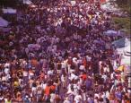
Population Geography:

Demography:

Demographics:

Growth Rate:

Rate of Natural Increase (r):

Net Migration:

Sub-replacement Fertility:

NOTES:

Why study population geography?

POPULATION GROWTH

POPULATION DECLINE

THE GLOBAL VILLAGE

NOTES:

Birth Rate in Quebec Lowest Since 1908


by INGRID PERITZ
Globe and Mail, October 4, 1999

Quebec is experiencing a baby bust this year and if trends continue the province will post the lowest number of births since the dawn of the century.

New figures by the Institut de la statistique du Québec show that total births this year have plunged 25 per cent since 1990. Researchers forcast that only 73,200 babies will be born in Quebec this year, a figure not seen since 1908.

“On a decade-by-decade basis, the drop in births is impressive,” said Normand Thibault of the statistics institute.

The findings are sure to add to the growing alarm over Quebec’s shrinking slice of the Canadian population. For most of the century after Confederation, Quebec weighed in at a third of the nation, a figure that helped assure its political clout.
But its population has already dropped below the psychological benchmark of 25 per cent.

Quebec has tried to aggressively reverse its plunging birth rate through baby bonuses, and, more recently, family-friendly policies such as universal $5-a-day daycare.

Despite the initiatives, Quebec women are choosing to have their children later, and many women in their 20s are shunning motherhood altogether, according to the new report. “The drop in the birth rate is particularly abrupt among women aged [20 to 29],” it says.

Quebeckers aren’t alone in shying away from having large families, since declining birth rates have become the norm in the Western world. However, there are fewer mitigating factors in Quebec: The province doesn’t attract its proportionate share of immigrants, and Quebeckers leave the province for other destinations in Canada.

Social upheaval since the collapse of the influence of the Catholic Church has played a role, some experts believe. Jacques Henripin, a leading demographer in Quebec, said Quebeckers’ tendency to shun marriage is less conducive to having children.

“Conjugal instability is particularly strong in Quebec, and that doesn’t encourage people to have a lot of children,” he said in an interview yesterday. He cited studies showing that the children of parents who live together without getting married are three to four times more likely to see their parents split up than the children of married parents.

Demography remains a sensitive issue that colours the language debate in Quebec. The Parti Québécois has used its waning share of the Canadian population – which affects the amount of funds it gets in federal transfer payments – as an argument for sovereignty.

The article outlines concerns about the declining birth rate in Quebec. Describe the demographic trend outlined in the article. What are some factors that have led to this trend? Why study birth rates in Quebec and anywhere at all?

Differing Population Growths
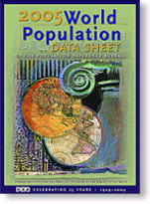

When using the World Population Data, notes that it does not include all countries. It includes all UN countries and non-UN members who have populations of 150,000 plus.
- “More developed countries”: all countries in Europe, North America, Australia, New Zealand, and Japan.
- “Less developed countries”: all countries in Africa, Asia (excluding Japan), Latin America and the Caribbean, and the regions of Melanesia, Micronesia, and Polynesia.
Use the World Population Data package to complete the following:
- Choose four countries whose populations are growing at a 1.0 percent rate of natural increase or less (some with negative rates of natural increase are decreasing).
- Choose four countries whose populations are growing at 3.0 percent or more.
- Create a table which includes the following data for each of the above selected countries: infant mortality rate, total fertility rate, population under age 15, life expectancy, percent of urban population, and Gross National Income in purchasing power parity per capita (GNI PPP). Examine the table you created for important differences, and note what you observe for each variable by group. For example:
 | High-Growth Countries | Low-Growth Countries
Infant Mortality | High infant mortality | Low infant mortality
Total Fertility
Population Under 15
Life Expectancy
Urban Population
Per Capita GNP
- Compare the characteristics for the above groups with countries that have a moderate rate of population growth.
- Describe how some countries such as Saudi Arabia and some of the oil-rich countries are exceptions to the generalizations you have made about fast-growing countries. Why are they different?
Predicting Future Trends
Use the World Population Data to answer the following questions:

- China and India have the largest populations in the world. Which of these two countries adds more people to its population annually? [Calculate the numbers added by applying the rate of natural increase to the population of each country. Reminder – the rate is a percent].

- What proportion of the world’s people live in Africa? In Asia? In North America? In Latin America? In Europe? In Oceania? What are the projected proportions by 2025 and 2050?

- What proportion of the world’s people live in less developed countries (LDCs) in the current year? In the more developed countries (MDCs)?

- What proportion of the world’s people is projected to live in LCDs and MCDs in 2025? In 2050?

- Using the data below, shade the countries on two maps – one map for 1950, and the other for 2050 – according to their population range. Choose darker colours for greater populations and lighter colours for lesser populations. Suggested ranges: less than 125 million, 126-250 million, and 500 million plus. Include all of the usual map essentials.

- Describe the spatial distribution of the countries for both years. Explain the overall change in distribution between the two years. What is the significance?
Most Populous Countries 2050
1. India 1,592,704,000
2. China 1,392,307,000
3. USA 394,976,000
4. Pakistan 304,700,000
5. Indonesia 284,640,000
6. Nigeria 258,108,000
7. Brazil 253,105,000
8. Bangladesh 242,937,000
9. Congo, DR 177,271,000
10. Ethiopia 170,190,000
11. Mexico 139,015,000
12. Philippines 127,068,000
13. Uganda 126,950,000
14. Egypt 125,916,000
15. Viet Nam 116,654,000
16. Japan 112,198,000
17. Russia 111,752,000
18. Iran 101,944,000
19. Turkey 101,208,000
20. Afghanistan 97,324,000
Most Populous Countries 1950
1. China 554,760,000
2. India 357,561,000
3. USA 157,813,000
4. Russia 102,702,000
5. Japan 83,625,000
6. Indonesia 79,538,000
7. Germany 68,376,000
8. Brazil 53,975,000
9. UK 49,816,000
10. Italy 47,104,000
11. France 41,829,000
12. Bangladesh 41,783,000
13. Ukraine 37,298,000
14. Pakistan 36,944,000
15. Nigeria 32,769,000
16. Spain 28,009,000
17. Mexico 27,737,000
18. Viet Nam 27,367,000
19. Poland 24,824,000
20. Egypt 21,834,000

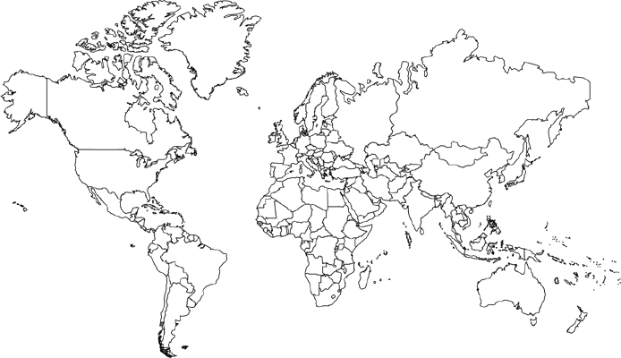

Population Pyramid Analysis
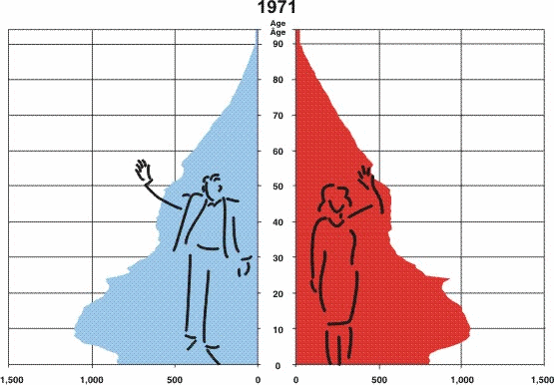
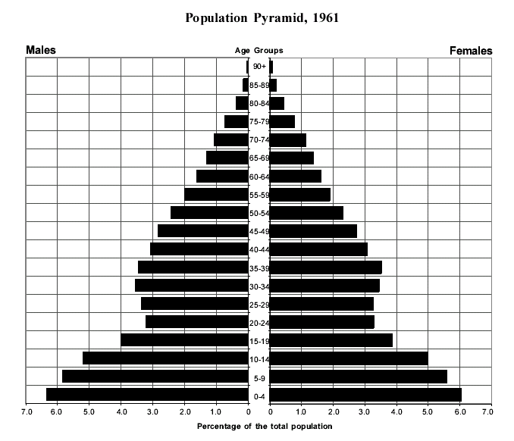
Canada’s

The pyramid narrows toward the top. This is because the death rate is higher among older
people than among younger people.

There are bulges and narrower parts in the middle part of the pyramid. The people in their 20s in 1961 were born during the
Depression, a time of economic hardship in Canada when people were having fewer children.

In 1961 the pyramid had a wide base. These are the baby boomers, a large group of people born between 1947 and 1966 when the economy was growing.

  - This is how Canada’s population was divided in 1961. How old would a person born during the Depression be today? __________________________ (give a range of ages).
  - Were your parents baby boomers? _______
  - How old would someone in the baby boomer generation be today? ______________________ (give range of ages)
  - There is a slight difference between the death rate of men and women. Which gender survives better into old age? ___________________.
  - Suggest two reasons why this might be the case:

Age Group | % of men | % of women
0-4  CANADA’S POPULATION IN 2006  Use the data on the right to complete Canada’s population pyramid for 2006. (Be sure to use a ruler, add appropriate labels, and darkly shade in each of the bars on the graph using red and blue.) | 5.4 | 5.1
5-9 | 5.8 | 5.5
10-14 | 6.6 | 6.2
15-19 | 6.9 | 6.4
20-24 | 7.2 | 6.7
25-29 | 7.0 | 6.7
30-34 | 7.0 | 6.7
35-39 | 7.3 | 7.1
40-44 | 8.4 | 8.2
45-49 | 8.3 | 8.1
50-54 | 7.3 | 7.3
55-59 | 6.4 | 6.4
60-64 | 4.8 | 4.9
65-69 | 3.7 | 3.9
70-74 | 3.0 | 3.4
75-79 | 2.4 | 3.0
80-84 | 1.5 | 2.4
85-89 | 0.7 | 1.4
90+ | 0.3 | 0.8

 |  |  |  |  |  |  |  |  |  | 90+
 |  |  |  |  |  |  |  |  |  | 85-89
 |  |  |  |  |  |  |  |  |  | 80-84
 |  |  |  |  |  |  |  |  |  | 75-79
 |  |  |  |  |  |  |  |  |  | 70-74
 |  |  |  |  |  |  |  |  |  | 65-69
 |  |  |  |  |  |  |  |  |  | 60-64
 |  |  |  |  |  |  |  |  |  | 55-59
 |  |  |  |  |  |  |  |  |  | 50-54
 |  |  |  |  |  |  |  |  |  | 45-49
 |  |  |  |  |  |  |  |  |  | 40-44
 |  |  |  |  |  |  |  |  |  | 35-39
 |  |  |  |  |  |  |  |  |  | 30-34
 |  |  |  |  |  |  |  |  |  | 25-29
 |  |  |  |  |  |  |  |  |  | 20-24
 |  |  |  |  |  |  |  |  |  | 15-19
 |  |  |  |  |  |  |  |  |  | 10-14
 |  |  |  |  |  |  |  |  |  | 5-9
 |  |  |  |  |  |  |  |  |  | 0-4
10% |  |  | MALES |  |  |  |  |  |  | 0% |  |  |  | FEMALES |  |  |  |  |  | 10%

1. Write the details of your age group and sex within the Canadian population.

age group _____________ sex ___________ percentage ________________

2. What single age group and sex represents the largest percentage of Canada’s population?

age group _____________ sex ___________ percentage ________________

3. Circle the 10-year age group that contains the largest percentage of the population.

0-9 10-19 20-29 30-39 40-49

4. What percentage of Canada’s population is male and what percentage is female? (Add the
percentages for each sex.)

males ______ females _______

5. Write in the percentages for males and females age 65 and over.

males ______ females _______

6. Explain why the 1996 population pyramid has a narrower base than that of the 1961 pyramid.
____________________________________________________________________________________________________________________________________________________________

7. a) Populations are frequently divided into two categories: people who are of working-age
(15-64) and people who are not of working age (under 15; 65 and over). Using the data on table,
give the percentage for each category in 1996:

working age ______ not of working age ______

b) List ways the working-age population contributes to Canada’s economic growth.
____________________________________________________________________________________________________________________________________________________________

c) Do you think the proportion of the population who are not of working age will change in the
future? If so, which part (under 15, or 65 and over)? Explain.
____________________________________________________________________________________________________________________________________________________________
Canada’s population is aging. This means that the median (or middle age) of Canadians is getting older.

Demographics has become one of the hot topics of our decade. Demographers study
population statistics and trends as you are doing in this activity. Among other things,
organizations depend on the work of demographers to help plan the location of businesses;
the number of schools, hospitals and retirement homes; the building of houses,
condominiums, and apartments; and the designing and marketing of products.

What does Canada’s aging population mean for Canadian society? Become a demographer, and predict what might happen as a larger percentage of Canadians is over 65 years old.

Part of Canadian Society | How Canada’s aging population will affect it
health care
housing
the people available to work (the work force)

job opportunities for younger Canadians

the sorts of things Canadians will want to buy

Predicting Population Pyramids

Using the statistics provided below, construct population pyramids for the following years: 1961, 1995, 2021, 2041. The data is in ten year increments (0-9, 10-19, etc.).

1961 m f 1995 m f 2021 m f 2041 m f
12.5 12.2 7.0 6.5 5.6 5.2 5.2 4.8
11.5 11.2 7.0 6.5 5.8 5.3 5.4 4.8
10.3 10.0 7.0 6.5 5.8 5.3 5.4 5.1
14.3 14.4 14.0 13.2 12.1 11.2 11.8 10.9
13.6 13.5 17.0 16.3 13.7 13.0 12.7 11.8
12.9 13.3 16.9 16.4 13.7 13.3 13.3 12.5
10.4 10.2 12.6 12.3 13.3 13.1 13.6 12.9
7.1 7.0 8.5 8.5 13.7 13.9 12.3 12.1
7.3 7.9 10.3 13.8 15.9 19.7 20.1 25.0

a) Describe each pyramid’s overall shape and situation.

b) Label the “baby boom” on your 1961 pyramid and the “baby boomers” progression on each of the subsequent pyramids.

c) Attempt to describe the economic situation in each pyramid.

d) Use the pyramids to confirm the “greying of Canada”.

e) Describe the changes in the birth and death rates of the pyramids.

f) What has happened to the sex ratio since the early 1960s?

g) Identify 2 socio-economic concerns the projected pyramid of 2041 poses for the future.

h) What percentage of the total population does the workforce comprise in each of the pyramids?

i) If you are a member of the workforce in the year 2041, what concerns might you have?

j) What is happening to the upper dependency load from the period 1961 to 2041?

k) What is happening to the lower dependency load from the period 1961 to 2041?

l) What do the expected changes in Canada’s dependency load mean for the future?

A Global Village of 100


If we could shrink the earth's population to a village of precisely 100 people, with all the existing human ratios remaining the same, it would look something like the following:

57 Asians
21 Europeans
14 from the Western Hemisphere, both north and south
8 Africans
52 would be female
48 would be male
70 would be non-white
30 would be white
70 would be non-Christian
30 would be Christian
89 would be heterosexual
11 would be homosexual
6 people would possess 59% of the entire world's wealth and all 6 would be from the United States.
80 would live in substandard housing
70 would be unable to read
50 would suffer from malnutrition
1 would be near death; 1 would be near birth
1 (yes, only 1) would have a college education
1 would own a computer

When one considers our world from such a compressed perspective, the need for acceptance, understanding and education becomes glaringly apparent.

The following is also something to ponder... If you woke up this morning with more health than illness...you are more blessed than the million who will not survive this week. If you have never experienced the danger of battle, the loneliness of imprisonment, the agony of torture, or the pangs of starvation ...you are ahead of 500 million people in the world. If you can attend a church meeting without fear of harassment, arrest, torture, or death...you are more blessed than three billion people in the world. If you have food in the refrigerator, clothes on your back, a roof overhead and a place to sleep...you are richer than 75% of this world. If you have money in the bank, in your wallet, and spare change in a dish someplace ... you are among the top 8% of the world's wealthy. If your parents are still alive and still married ... you are very rare, even in the United States and Canada.
A Global Village of 1000
If the world were a village of 1,000 people it would include:

* 584 Asians
* 124 Africans
* 95 Eastern and Western Europeans
* 84 Latin Americans
* 55 former Soviets (this includes Lithuanians, Latvians, Estonians, and other national groups)
* 52 North Americans
* 6 Australians and New Zealanders

The people of the village would speak:

* 165 Mandarin
* 86 English
* 83 Hindu/Urdi
* 64 Spanish
* 58 Russian
* 37 Arabic

The above list accounts for the mother tongues of only half the village. The other half speak (in descending order of frequency)

* Bengali
* Portuguese
* Indonesian
* Japanese
* German
* French
* and 200 other languages.

In this village of 1,000 there are:

* 329 Christians (among them 187 Catholics, 84 Protestants, and 31 Orthodox)
* 178 Muslims
* 167 "Non religious"
* 60 Buddhists
* 45 Atheists
* 32 Hindus
* 3 Jews
* 86 of other religions

One-third of the 1,000 people in the world village are children, and only 60 are over the age of 65. Half the children are immunized against preventable diseases such as measles and polio. Just under half of the married women in the village have access to and use modern contraceptives.

This year 28 babies will be born. Ten people will die, 3 of them for lack of food, 1 from cancer. Two of the deaths will be of babies born within the year. One person of that 1,000 in the village is infected with HIV; that person most likely has not yet developed a full-blown case of AIDS.

With the 28 births and 10 deaths, the population of the village next year will be 1,018.

In this 1,000 person community, 200 people receive 75 percent of the income; another 200 receive only 2 percent of the income.

Only 70 people of the 1,000 own an automobile (although some of the 70 own more than one car).

About one-third have access to clean, safe drinking water.

Of the 670 adults in the village, half are illiterate.

The village has 6 acres of land per person-6000 acres in all-of which:

* 700 acres are cropland,
* 1,400 acres are pasture,
* 1,900 acres are woodland,
* 2,000 acres desert, tundra, pavement, and other wasteland.

The woodland is declining rapidly; the wasteland is increasing. The other land categories are roughly stable. The village allocates 83 percent of its fertilizer to 40 percent of its cropland-that owned by the richest and best fed 270 people. Excess fertilizer running off this land causes pollution in lakes and wells. The remaining 60 percent of the land, with its 17 percent of the fertilizer, produces only 28 percent of the food but feeds 73 percent of the people. The average grain yield on that land is one-third the harvest achieved by the richer villagers.

In the village of 1,000 people, there are:

* 5 soldiers
* 7 teachers
* 1 doctor
* 3 refugees driven from home by war or drought

The village has a total yearly budget, public and private, of over $3 million - $3,000 per person if it is distributed evenly (which, as we have already seen, it isn't). Of the total $3 million:

* $181,000 goes to weapons and warfare
* $159,000 to education
* $132,000 to health care

The village has buried beneath it enough explosive power in nuclear weapons to blow itself to smithereens many times over. These weapons are under the control of just 100 of the people. The other 900 are watching them with deep anxiety, wondering whether they can learn to get along together; and if they do, whether they might set off the weapons anyway through inattention or technical bungling; and if they ever decide to dismantle the weapons, where in the world village will they dispose of the radioactive materials of which the weapons are made?

